

|  |
| --- |
| 11/A-14  Utku ÜNVER |
|  |

25.04.2023

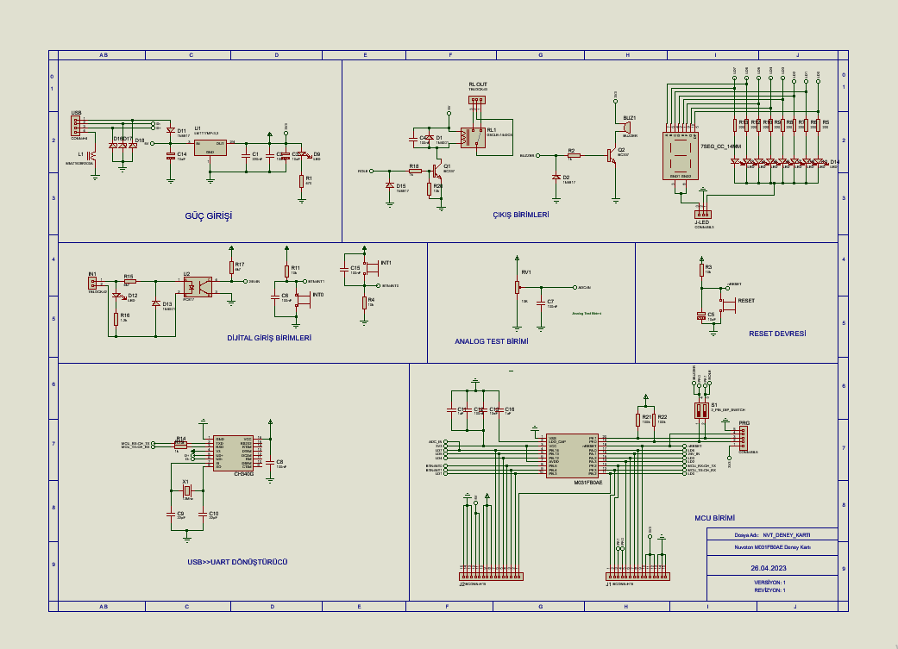

GENEL BASKI DEVRE GÖRÜNÜŞÜ

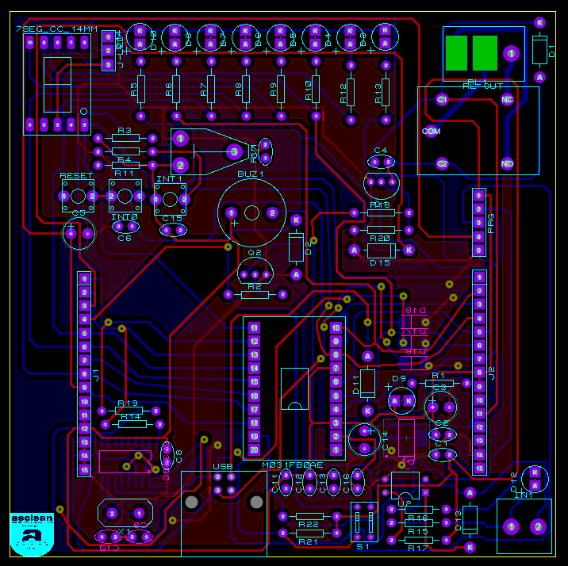

ALT KATMAN YERLEŞİM PLANI

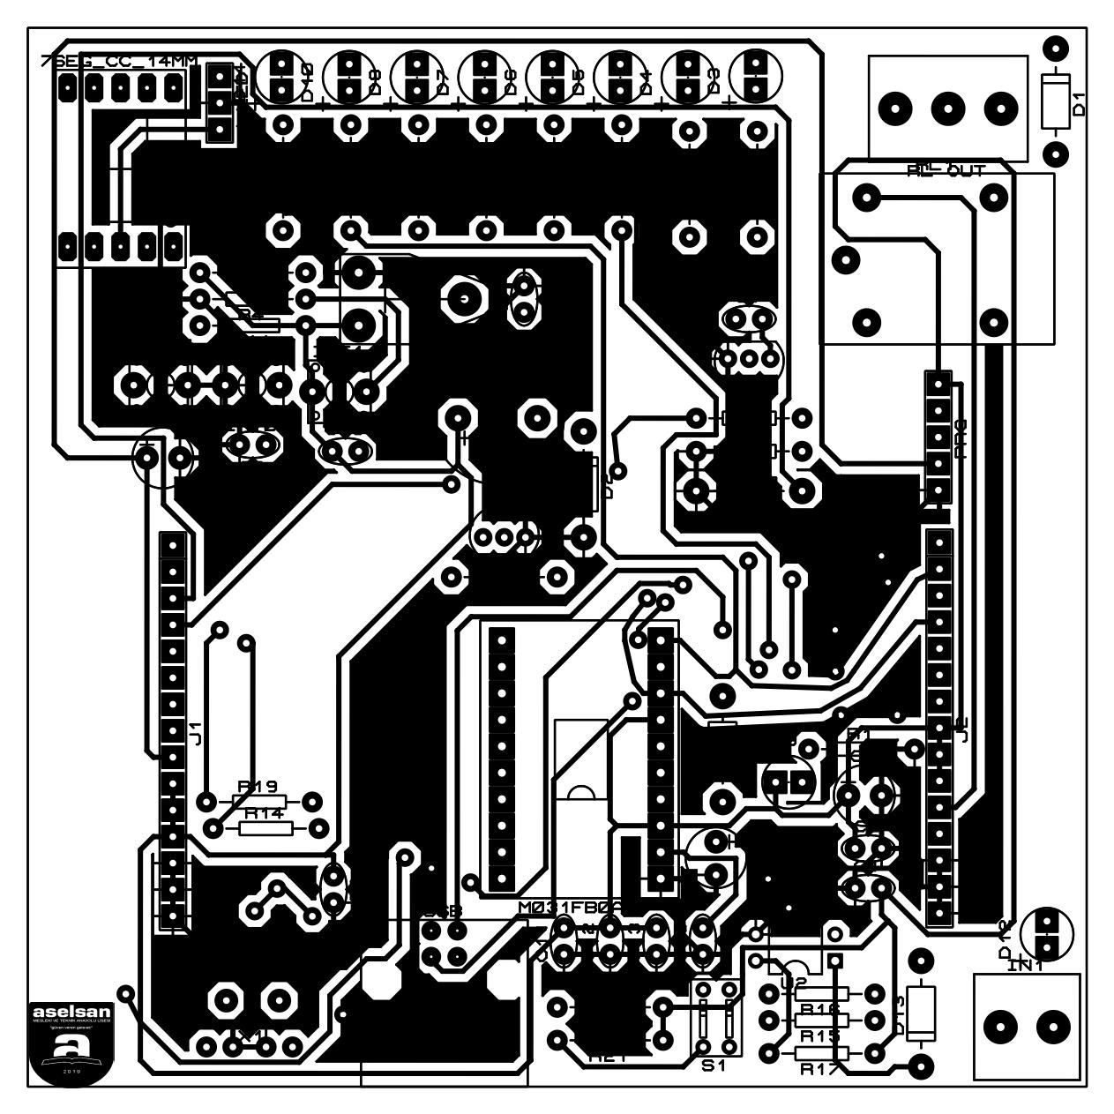

ÜST KATMAN YERLEŞİM PLANI

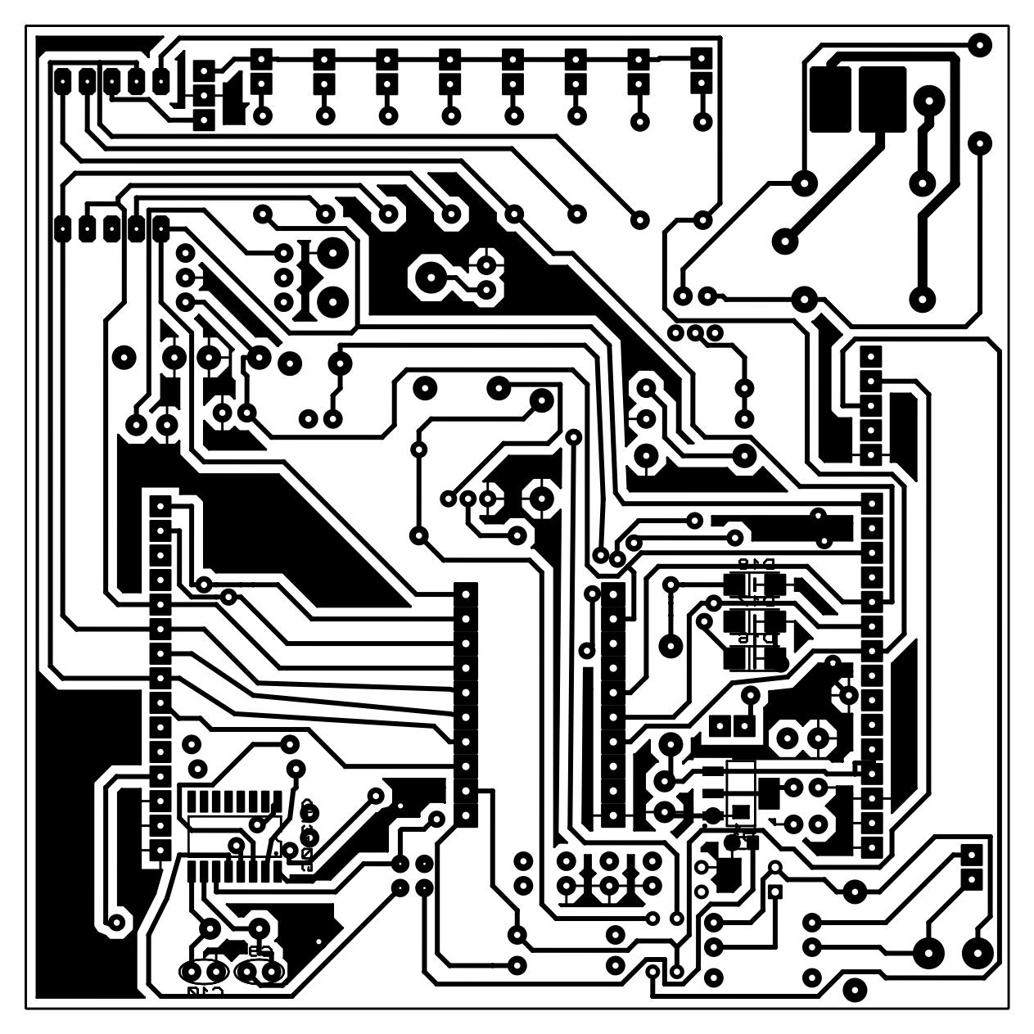

**Bill Of Materials for NVT_DENEY_KARTI_V1_REV2_6**

Design Title NVT_DENEY_KARTI_V1_REV2_6

Author

Document Number Revision

Design Created 26 Şubat 2023 Pazar

Design Last Modified 19 Mart 2023 Pazar

Total Parts In Design 79

|  |  |  |  |  |
| --- | --- | --- | --- | --- |
| **Category** | **Quantity** | **References** | **Value** | **PCB Package** |
| **Capacitors** | **1** | **C1** | **220nF** | **CAP10** |
| **Capacitors** | **7** | **C2,C6-C7,C11,C13,C15-**  **C16** | **100nF** | **CAP10** |
| **Capacitors** | **3** | **C3-C4,C14** | **10uF** | **ELEC-RAD13** |
| **Capacitors** | **1** | **C5** | **1uf** | **cap10** |
| **Capacitors** | **2** | **C8-C9** | **22pF** | **1206** |
| **Capacitors** | **1** | **C10** | **1uF** | **CAP10** |
| **Capacitors** | **1** | **C12** | **10nF** | **CAP10** |
| **Resistors** | **1** | **R1** | **470** | **RES40** |
| **Resistors** | **8** | **R2-R9** | **220** | **RES40** |
| **Resistors** | **4** | **R10-R12,R20** | **10k** | **RES40** |
| **Resistors** | **2** | **R13-R14** | **100k** | **RES40** |
| **Resistors** | **2** | **R15,R17** | **4k7** | **RES40** |
| **Resistors** | **1** | **R16** | **1.2K** | **RES40** |
| **Resistors** | **4** | **R18-R19,R21-R22** | **1k** | **RES40** |
| **Integrated**  **Circuits** | **1** | **U1** | **LM1117MP-3,3** | **SOT230P700X180-4** |
| **Integrated**  **Circuits** | **1** | **U2** | **PC817** | **DIL04** |
| **Integrated**  **Circuits** | **1** | **U3** | **M031FB0AE** | **TSSOP-DIL20** |
| **Integrated**  **Circuits** | **1** | **U4** | **CH340G** | **SOP16** |
| **Transistors** | **2** | **Q1-Q2** | **BC337** | **TO92** |
| **Diodes** | **10** | **D1-D9,D12** | **LED** | **LED** |
| **Diodes** | **1** | **D10** | **7_SEG_CC_14MM** | **7_SEG_14MM_CC_DISPLAY_FOOTPRNT** |
| **Diodes** | **3** | **D11,D15-D16** | **1N5817** | **DO41** |
| **Diodes** | **2** | **D13-D14** | **1N4001** | **DO41** |
| **Diodes** | **3** | **D17-D19** | **SMAJ7.0A** | **DO214** |
| **Miscellaneous** | **1** | **BUZ1** | **BUZZER** | **HPA13A** |
| **Miscellaneous** | **1** | **IN1** | **TBLOCK-I2** | **TBLOCK-I2** |
| **Miscellaneous** | **3** | **INT0-INT1,RESET** | **6x6 2 pin tach**  **buton** | **BUTON_2** |
| **Miscellaneous** | **2** | **J3-J4** | **CONN-H15** | **CONN-SIL15** |
| **Miscellaneous** | **1** | **J-LED** | **CONN-SIL3** | **CONN-SIL3** |
| **Miscellaneous** | **1** | **L1** | **30R FERRITE BEAD** | **0805** |
| **Miscellaneous** | **1** | **PRG** | **CONN-SIL5** | **CONN-SIL5** |
| **Miscellaneous** | **1** | **RL1** | **G5CLE-14-DC5** | **RLY-OMRON-C4** |
| **Miscellaneous** | **1** | **RL OUT** | **TBLOCK-I3** | **TBLOCK-I3** |
| **Miscellaneous** | **1** | **RV1** | **10K** | **PRE-HMIN** |
| **Miscellaneous** | **1** | **S1** | **2_PIN_DIP_SWITCH** | **2_PIN_DIP_SWITCH** |
| **Miscellaneous** | **1** | **USB** | **CONN-H4** | **USB-B** |
| **Miscellaneous** | **1** | **X1** | **12MHz** | **XTAL18** |

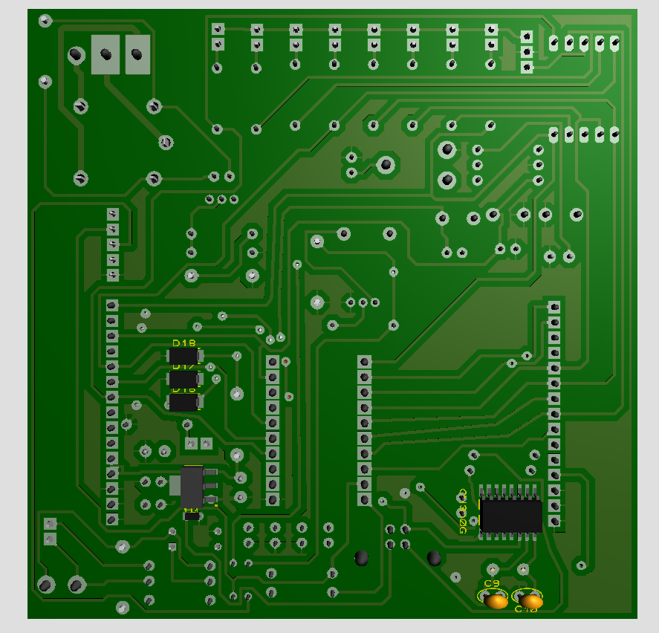 ALT KATMAN 3D

GÖRÜNTÜ

ÖN KATMAN 3D

GÖRÜNTÜ

